**Practical No.02**

**Introduction to ASP.NET**

**Aim:**

To demonstrate the postback and crosspage posting, basic and advanced asp controls, Angular JS, JQuery, NodeJS and Master Page – Content page using ASP.Net web application.

**Q1. Design asp.net web form to demonstrate various events in asp.net page life cycle.**

**Design:**

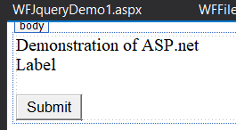

**Code:**

**WFPageLifeCycle.aspx**

<%@ Page Language="C#" AutoEventWireup="true" CodeBehind="WFPageLifeCycle.aspx.cs" Inherits="PracticalNo2All.WFPageLifeCycle" %>

<!DOCTYPE html>

<html xmlns="http://www.w3.org/1999/xhtml">

<head runat="server">

<title></title>

</head>

<body>

<form id="form1" runat="server">

<div>

<asp:Label ID="lblDemo" runat="server" Text="Demonstration of ASP.net"></asp:Label>

<br /><asp:Label ID="lblDemo2" runat="server" Text="Label"></asp:Label>

<br />

<br/><asp:Button ID="btnSubmit" runat="server" Text="Submit" OnClick="btnSubmit_Click" />

</div>

</form>

</body>

</html>

**WFPageLifeCycle.aspx.cs**

using System;

using System.Collections.Generic;

using System.Linq;

using System.Web;

using System.Web.UI;

using System.Web.UI.WebControls;

namespace PracticalNo2All

{

public partial class WFPageLifeCycle : System.Web.UI.Page

{

// Event Handling Methods

protected void Page_PreInit(object sender, EventArgs e)

{

lblDemo2.Text = lblDemo2.Text + "<br/>" + "PreInit";

}

protected void Page_Init(object sender, EventArgs e)

{

lblDemo2.Text = lblDemo2.Text + "<br/>" + "Init";

}

protected void Page_InitComplete(object sender, EventArgs e)

{

lblDemo2.Text = lblDemo2.Text + "<br/>" + "InitComplete";

}

// Event

protected override void OnPreLoad(EventArgs e)

{

lblDemo2.Text = lblDemo2.Text + "<br/>" + "PreLoad";

}

protected void Page_Load(object sender, EventArgs e)

{

lblDemo2.Text = lblDemo2.Text + "<br/>" + "Load";

}

protected void Page_LoadComplete(object sender, EventArgs e)

{

lblDemo2.Text = lblDemo2.Text + "<br/>" + "Load Complete";

}

protected override void OnPreRender(EventArgs e)

{

lblDemo2.Text = lblDemo2.Text + "<br/>" + "PreRender";

}

protected override void OnSaveStateComplete(EventArgs e)

{

lblDemo2.Text = lblDemo2.Text + "<br/>" + "On Save State Complete";

}

protected void Page_UnLoad(object sender, EventArgs e)

{

lblDemo2.Text = lblDemo2.Text + "<br/>" + "UnLoad";

}

protected void btnSubmit_Click(object sender, EventArgs e)

{

//lblDemo2.ForeColor = System.Drawing.Color.AliceBlue;

lblDemo2.Text = lblDemo2.Text + "<br/>" + "btnSubmit_Click";

}

}

}

**Output:**

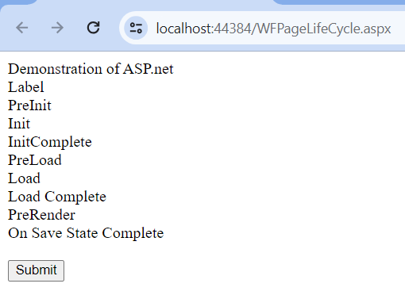

**Q.2 Design asp.net web form to demonstrate postback posting, cross-page posting and auto postback.**

**Design:**

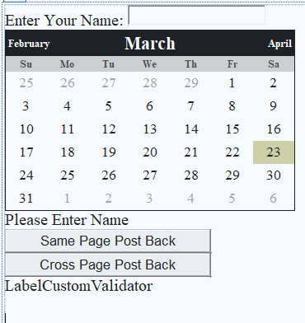

**Code:**

**WFPostBack.aspx**

<%@ Page Language="C#" AutoEventWireup="true" CodeBehind="WFPostDemo.aspx.cs" Inherits="PracticalNo2All.WFPostDemo" %>

<!DOCTYPE html>

<html xmlns="http://www.w3.org/1999/xhtml">

<head runat="server">

<title></title>

</head>

<body>

<form id="form1" runat="server">

<div>

<asp:Label ID="Label1" runat="server" Text="Enter Your Name: "></asp:Label>

<asp:TextBox ID="txtName" runat="server"></asp:TextBox>

<asp:Calendar ID="Calendar1" runat="server" BackColor="White" BorderColor="Black" DayNameFormat="Shortest" Font-Names="Times New Roman" Font-Size="10pt" ForeColor="Black" Height="220px" NextPrevFormat="FullMonth" TitleFormat="Month" Width="352px">

<DayHeaderStyle BackColor="#CCCCCC" Font-Bold="True" Font-Size="7pt" ForeColor="#333333" Height="10pt" />

<DayStyle Width="14%" />

<NextPrevStyle Font-Size="8pt" ForeColor="White" />

<OtherMonthDayStyle ForeColor="#999999" />

<SelectedDayStyle BackColor="#CC3333" ForeColor="White" />

<SelectorStyle BackColor="#CCCCCC" Font-Bold="True" Font-Names="Verdana" Font-Size="8pt" ForeColor="#333333" Width="1%" />

<TitleStyle BackColor="Black" Font-Bold="True" Font-Size="13pt" ForeColor="White" Height="14pt" />

<TodayDayStyle BackColor="#CCCC99" />

</asp:Calendar>

<asp:RequiredFieldValidator ID="RequiredFieldValidator1" runat="server" ControlToValidate="txtName" ErrorMessage="Please Enter Name"></asp:RequiredFieldValidator>

<br />

<asp:Button ID="btnPostBack" runat="server" OnClick="btnPostBack_Click" Text="Same Page Post Back" Width="250px" />

<br />

<asp:Button ID="btnCross" runat="server" OnClick="btnCross_Click" PostBackUrl="~/WFPostiDemo2.aspx" Text="Cross Page Post Back" Width="250px" />

<br />

<asp:Label ID="lblData" runat="server" Text="Label"></asp:Label>

<asp:CustomValidator ID="CustomValidator1" runat="server" ControlToValidate="txtName" ErrorMessage="CustomValidator"></asp:CustomValidator>

<br />

<br />

</div>

</form>

</body>

</html>

**WFPostBack.aspx.cs**

using System;

using System.Collections.Generic;

using System.Linq;

using System.Web;

using System.Web.UI;

using System.Web.UI.WebControls;

namespace PracticalNo2All

{

public partial class WFPageLifeCycle : System.Web.UI.Page

{

// Event Handling Methods

protected void Page_PreInit(object sender, EventArgs e)

{

lblDemo2.Text = lblDemo2.Text + "<br/>" + "PreInit";

}

protected void Page_Init(object sender, EventArgs e)

{

lblDemo2.Text = lblDemo2.Text + "<br/>" + "Init";

}

protected void Page_InitComplete(object sender, EventArgs e)

{

lblDemo2.Text = lblDemo2.Text + "<br/>" + "InitComplete";

}

// Event

protected override void OnPreLoad(EventArgs e)

{

lblDemo2.Text = lblDemo2.Text + "<br/>" + "PreLoad";

}

protected void Page_Load(object sender, EventArgs e)

{

lblDemo2.Text = lblDemo2.Text + "<br/>" + "Load";

}

protected void Page_LoadComplete(object sender, EventArgs e)

{

lblDemo2.Text = lblDemo2.Text + "<br/>" + "Load Complete";

}

protected override void OnPreRender(EventArgs e)

{

lblDemo2.Text = lblDemo2.Text + "<br/>" + "PreRender";

}

protected override void OnSaveStateComplete(EventArgs e)

{

lblDemo2.Text = lblDemo2.Text + "<br/>" + "On Save State Complete";

}

protected void Page_UnLoad(object sender, EventArgs e)

{

lblDemo2.Text = lblDemo2.Text + "<br/>" + "UnLoad";

}

protected void btnSubmit_Click(object sender, EventArgs e)

{

//lblDemo2.ForeColor = System.Drawing.Color.AliceBlue;

lblDemo2.Text = lblDemo2.Text + "<br/>" + "btnSubmit_Click";

}

}

}

**Output:**

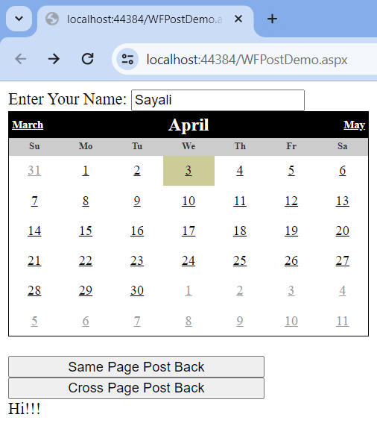

**Same Page Post Back:**

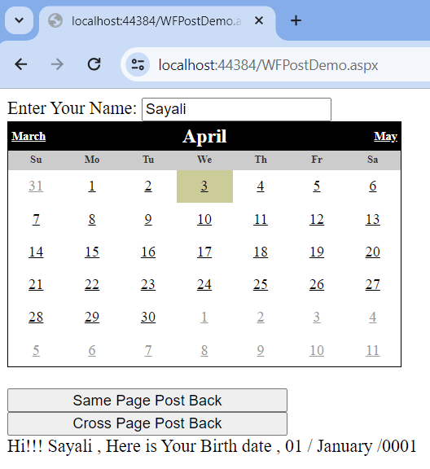

**Cross Page Post Back:**

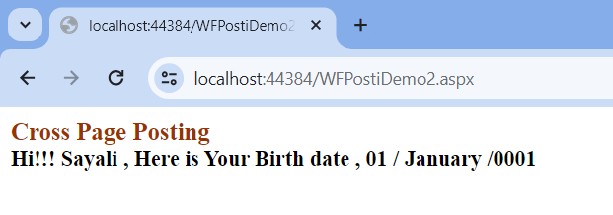

**Q.3. Design asp.net web form to demonstrate FileUpload and AdRotator controls.**

**Design:**

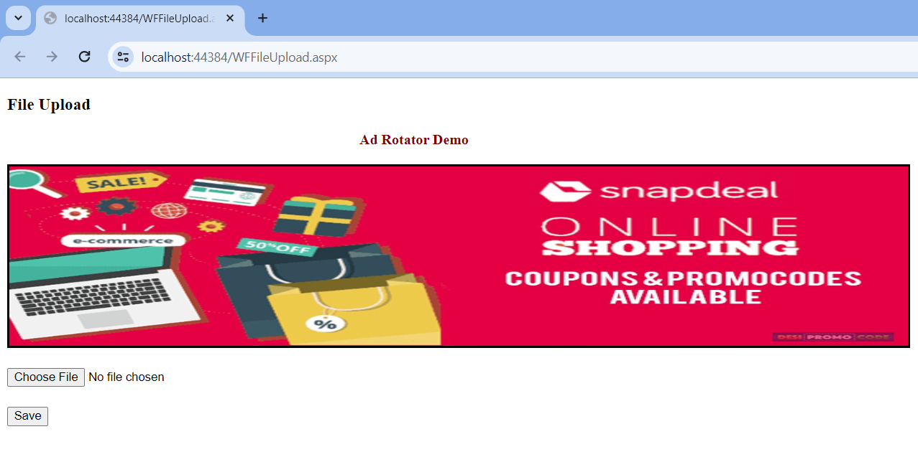

**Code:**

**WFFileUpload.aspx**

<%@ Page Language="C#" AutoEventWireup="true" CodeBehind="WFFileUpload.aspx.cs" Inherits="PracticalNo2All.WFFileUpload" %>

<!DOCTYPE html>

<html xmlns="http://www.w3.org/1999/xhtml">

<head runat="server">

<title></title>

</head>

<body>

<h3>File Upload</h3>

<asp:Label ID="Label1" runat="server" Text="Ad Rotator Demo" Font-Bold="True" ForeColor="Maroon"></asp:Label>

<br />

<br />

<asp:AdRotator ID="AdRotator1" runat="server" AdvertisementFile="~/XMLFile1.xml" BackColor="#CCCCCC" BorderColor="Black" BorderStyle="Solid" Height="200px" ImageUrlField="" Width="1000px" />

<form id="form1" runat="server">

<div>

<br />

<asp:FileUpload ID="FileUpload1" runat="server" Height="25px" />

<br />

<br />

<asp:Button ID="btnSubmit" runat="server" OnClick="btnSubmit_Click" Text="Save" />

<br />

<br />

<asp:Label ID="lblMessage" runat="server"></asp:Label>

</div>

</form>

</body>

</html>

**WFFileUpload.aspx.cs**

using System;

using System.Collections.Generic;

using System.IO;

using System.Linq;

using System.Text;

using System.Web;

using System.Web.UI;

using System.Web.UI.WebControls;

namespace PracticalNo2All

{

public partial class WFFileUpload : System.Web.UI.Page

{

protected void Page_Load(object sender, EventArgs e)

{

}

protected void btnSubmit_Click(object sender, EventArgs e)

{

StringBuilder sb = new StringBuilder();

if (FileUpload1.HasFile)

{

try

{

sb.AppendFormat(" Uploading File: {0} " , FileUpload1.FileName);

// Saving String

string filename = Path.GetFileName(FileUpload1.FileName);

FileUpload1.SaveAs(Server.MapPath("~/") + filename);

//Showing File Information

sb.AppendFormat("<br/> Save As: {0} ", FileUpload1.PostedFile.FileName);

sb.AppendFormat("<br/> Content Type: {0} ", FileUpload1.PostedFile.ContentType);

sb.AppendFormat("<br/> File Length: {0} ", FileUpload1.PostedFile.ContentLength);

}

catch(Exception ex)

{

sb.Append("<br/> Error: <br/>");

sb.AppendFormat("Unable to Save File: {0} ", ex.Message);

}

lblMessage.Text = sb.ToString();

}

else

{

lblMessage.Text = "Sorry You Haven't Select any File";

}

}

}

}

**Output:**

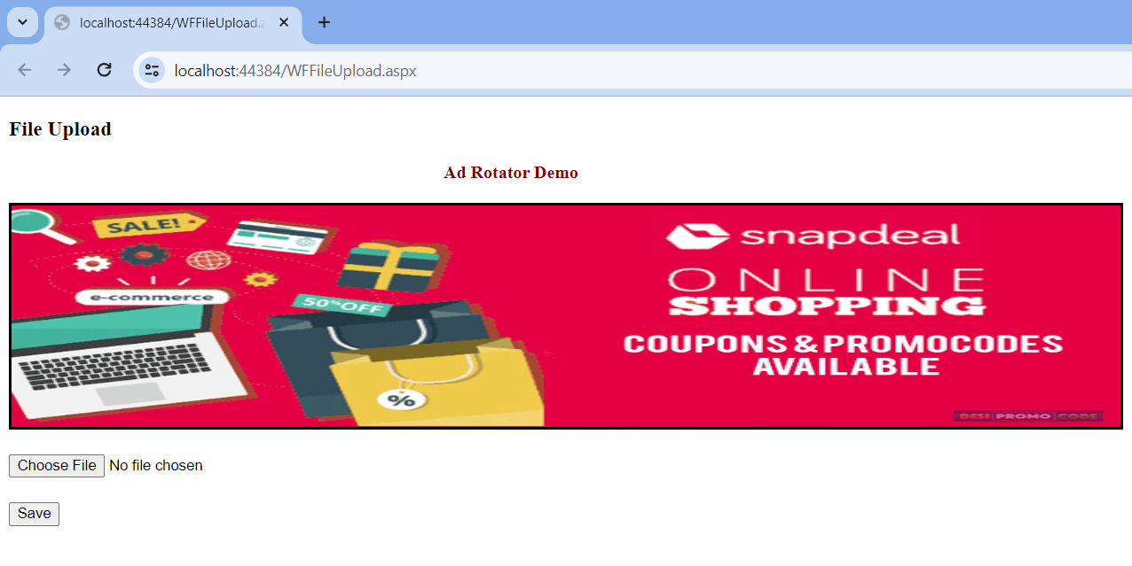

**After Clicking > Choose File**

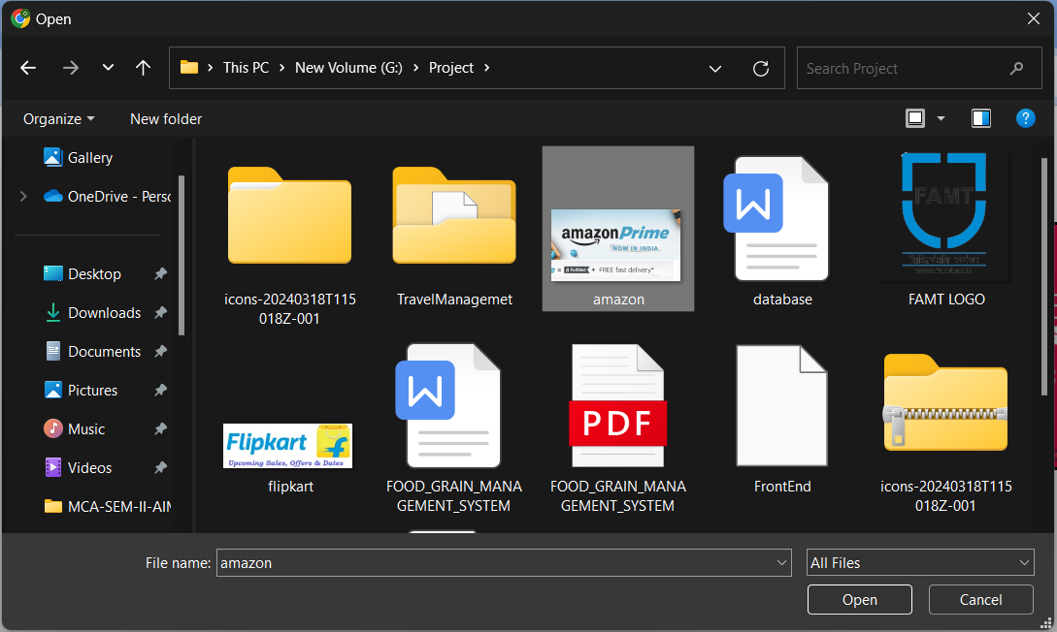

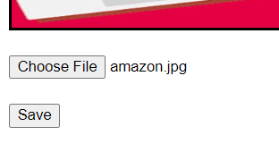

**After Clicking > Save**

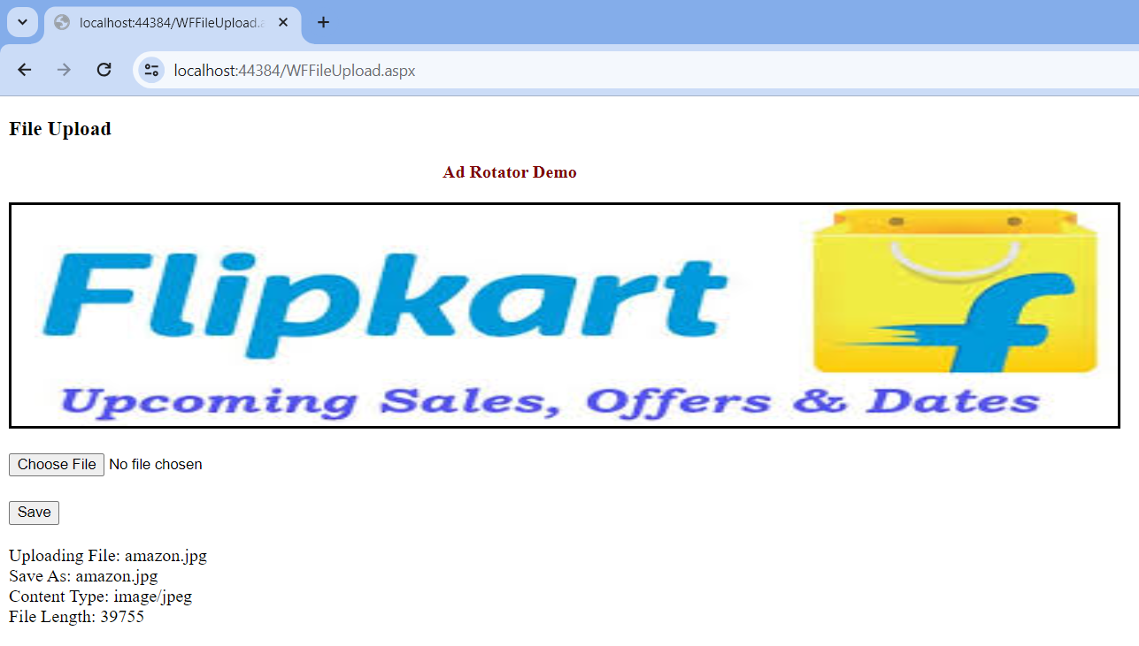

**XMLFile1.xml**

<?xml version="1.0" encoding="utf-8" ?>

<Advertisements>

<Ad>

<ImageUrl>Images/amazon.jpg</ImageUrl>

<NavigateUrl>https://www.amazon.in/</NavigateUrl>

<AlternateText>

Amazon India Online Shopping

</AlternateText>

<Impressions>5</Impressions>

<Keyword>shopping</Keyword>

</Ad>

<Ad>

<ImageUrl>Images/flipkart.jpg</ImageUrl>

<NavigateUrl>https://www.flipkart.com/</NavigateUrl>

<AlternateText>

FlipKart India Online Shopping

</AlternateText>

<Impressions>5</Impressions>

<Keyword>shopping</Keyword>

</Ad>

<Ad>

<ImageUrl>Images/snapdeal.jpg</ImageUrl>

<NavigateUrl>https://www.snapdeal.co.in/</NavigateUrl>

<AlternateText>

SnapDeal India Online Shopping

</AlternateText>

<Impressions>5</Impressions>

<Keyword>shopping</Keyword>

</Ad>

</Advertisements>

**Q.4. Design asp.net web form to demonstrate Validation controls in asp.net. After successful submission of data, show same data on another page.**

**Design:**

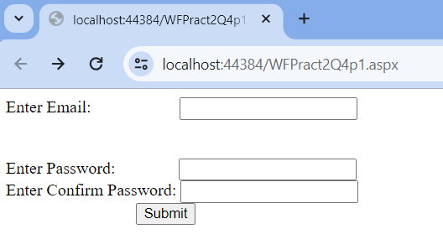

**Code:**

**WFPract2Q1.aspx**

<%@ Page Language="C#" AutoEventWireup="true" CodeBehind="WFPract2Q4p1.aspx.cs" Inherits="PracticalNo2All.WFPract2Q4p1" %>

<!DOCTYPE html>

<html xmlns="http://www.w3.org/1999/xhtml">

<head runat="server">

<title></title>

</head>

<body>

<form id="form1" runat="server">

<div>

<asp:Label ID="Label1" runat="server" Text="Enter Email: "></asp:Label>

<asp:TextBox ID="TextBox1" runat="server"></asp:TextBox>

<asp:RequiredFieldValidator ID="RequiredFieldValidator1" runat="server" ControlToValidate="TextBox1" Display="Dynamic" ErrorMessage="Please Enter Proper Email"></asp:RequiredFieldValidator>

<br />

<asp:CompareValidator ID="CompareValidator1" runat="server" ControlToCompare="TextBox2" ControlToValidate="TextBox3" Display="Dynamic" ErrorMessage="Passwords Are Not Same"></asp:CompareValidator>

<br />

<asp:RegularExpressionValidator ID="RegularExpressionValidator1" runat="server" ControlToValidate="TextBox1" Display="Dynamic" ErrorMessage="Enter Valid Email " ValidationExpression="\w+([-+.']\w+)*@\w+([-.]\w+)*\.\w+([-.]\w+)*"></asp:RegularExpressionValidator>

<br />

Enter Password:

<asp:TextBox ID="TextBox2" runat="server"></asp:TextBox>

<asp:RequiredFieldValidator ID="RequiredFieldValidator2" runat="server" ControlToValidate="TextBox2" Display="Dynamic" ErrorMessage="Please Enter Passwoer"></asp:RequiredFieldValidator>

<br />

Enter Confirm Password:

<asp:TextBox ID="TextBox3" runat="server"></asp:TextBox>

<asp:RequiredFieldValidator ID="RequiredFieldValidator3" runat="server" ControlToValidate="TextBox3" ErrorMessage="Confirm Password Enter"></asp:RequiredFieldValidator>

<br />

<asp:Button ID="btnSubmit" runat="server" OnClick="btnSubmit_Click" PostBackUrl="~/WFPract2Q4P2.aspx" Text="Submit" />

</div>

</form>

</body>

</html>

**WFPract2Q2.aspx**

<%@ Page Language="C#" AutoEventWireup="true" CodeBehind="WFPract2Q4P2.aspx.cs" Inherits="PracticalNo2All.WFPract2Q4P2" %>

<!DOCTYPE html>

<html xmlns="http://www.w3.org/1999/xhtml">

<head runat="server">

<title></title>

</head>

<body>

<form id="form1" runat="server">

<div>

<div><b>

<asp:Label ID="Label1" runat="server" Font-Names="Times New Roman" Font-Size="Large" ForeColor="#993300" Text="Cross Page Posting"></asp:Label>

<br />

<asp:Label ID="lblEmail" runat="server" Text="lblEmail"></asp:Label>

</b></div>

</div>

</form>

</body>

</html>

**WFPract2Q2.aspx.cs**

using System;

using System.Collections.Generic;

using System.Linq;

using System.Web;

using System.Web.UI;

using System.Web.UI.WebControls;

namespace PracticalNo2All

{

public partial class WFPract2Q4P2 : System.Web.UI.Page

{

protected void Page_Load(object sender, EventArgs e)

{

if (Page.PreviousPage != null && PreviousPage.IsCrossPagePostBack)

{

// creating conntrol

TextBox txtEmail = new TextBox();

txtEmail = (TextBox)(PreviousPage.FindControl("TextBox1"));

lblEmail.Text = "Hi!!! " + txtEmail.Text + " ";

}

else

{

lblEmail.Text = "Hello Sir";

}

}

}

}

**Output:**

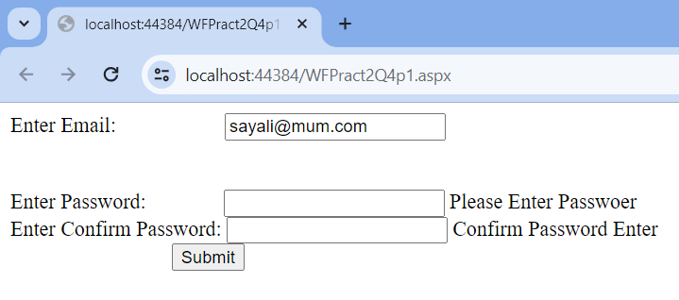

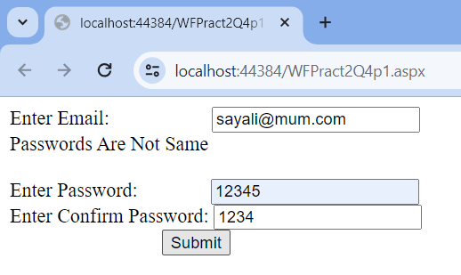

***Note: Add this line to the Web.Config File inside the Configuration Tag :***

<appSettings>

<add key="ValidationSettings:UnobtrusiveValidationMode" value ="None"/>

</appSettings>

**Q.5 Design asp.net web application to demonstrate Master Page and Content Pages in asp.net.**

**Code:**

**SiteMaster.Master**

<%@ Master Language="C#" AutoEventWireup="true" CodeBehind="SiteMaster.master.cs" Inherits="DemoMaster.SiteMaster" %>

<!DOCTYPE html>

<html>

<head runat="server">

<title>Hello World</title>

<asp:ContentPlaceHolder ID="head" runat="server">

</asp:ContentPlaceHolder>

</head>

<body>

<h2>Hello I am Master Page</h2>

<form id="form1" runat="server">

<div>

<asp:ContentPlaceHolder ID="ContentPlaceHolder1" runat="server">

</asp:ContentPlaceHolder>

</div>

</form>

</body>

</html>

**WebForm1.aspx**

<%@ Page Title="Hello Content" Language="C#" MasterPageFile="~/SiteMaster.Master" AutoEventWireup="true" CodeBehind="WebForm1.aspx.cs" Inherits="DemoMaster.WebForm1" %>

<asp:Content ID="Content1" ContentPlaceHolderID="head" runat="server">

</asp:Content>

<asp:Content ID="Content2" ContentPlaceHolderID="ContentPlaceHolder1" runat="server">

<h3>Hello Content Page</h3>

</asp:Content>

**Output:**

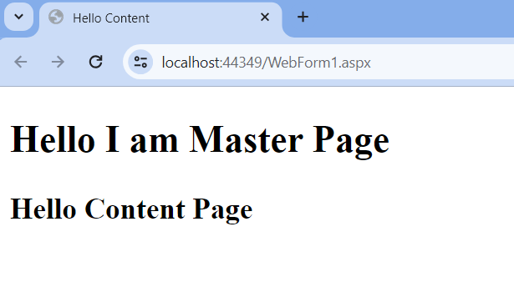

**Q.6 Design asp.net web form to demonstrate JQuery (use CDN JQuery library).**

**Code:**

**WF_JQuery_Demo2.aspx**

<%@ Page Language="C#" AutoEventWireup="true" CodeBehind="WF_JQuery_Demo2.aspx.cs" Inherits="PracticalNo2All.WF_JQuery_Demo2" %>

<!DOCTYPE html>

// **cdn is used here**

**<script type="text/javascript" src="//ajax.googleapis.com/ajax/libs/jquery/3.7.1/jquery.min.js"></script>**

<script type="text/javascript">

$(document).ready(function () {

$("#btnSubmit").click(function () {

alert("Alert Using JQuery");

});

});

</script>

<html xmlns="http://www.w3.org/1999/xhtml">

<head runat="server">

<title></title>

</head>

<body>

<form id="form1" runat="server">

<div>

<div>

<br />

<br />

<br />

<asp:Button ID="btnSubmit" runat="server" OnClick="Button1_Click" Text="Submit" />

</div>

</div>

</form>

</body>

</html>

**Output:**

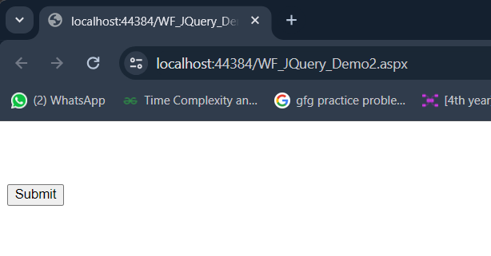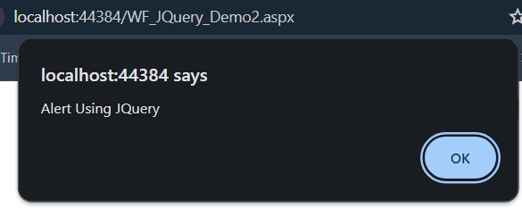

**Click Here**

**Q.7 Design asp.net web form to demonstrate JQuery (download and use local JQuery library).**

**Code:**

**WFJQueryDemo1.aspx**

<%@ Page Language="C#" AutoEventWireup="true" CodeBehind="WFJqueryDemo1.aspx.cs" Inherits="PracticalNo2All.WFJqueryDemo1" %>

<!DOCTYPE html>

<script type="text/javascript" src ="/Scripts/jquery-3.7.1.min.js"></script>

<script type="text/javascript">

$(document).ready(function () {

$("#btnSubmit").click(function () {

alert("Alert Using JQuery");

});

});

</script>

<html xmlns="http://www.w3.org/1999/xhtml">

<head runat="server">

<title></title>

</head>

<body>

<form id="form1" runat="server">

<div>

<br />

<br />

<br />

<asp:Button ID="btnSubmit" runat="server" OnClick="Button1_Click" Text="Submit" />

</div>

</form>

</body>

</html>

**Output:**

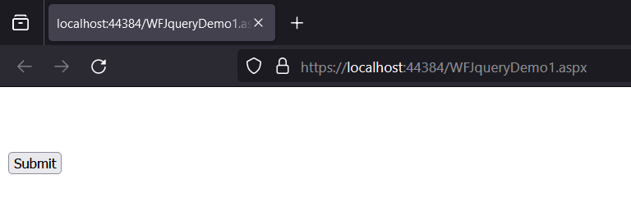

**Click Here**

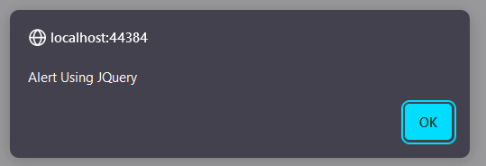

**Q.8 Design asp.net web form to demonstrate AngularJS (use CDN).**

**Code:**

**WFAngularJs.aspx**

<%@ Page Language="C#" AutoEventWireup="true" CodeBehind="WFAngularJS.aspx.cs" Inherits="PracticalNo2All.WFAngularJS" %>

<!DOCTYPE html>

<!-- <script src="/Scripts/angular.min.js"></script> -->

<script src="//ajax.googleapis.com/ajax/libs/angularjs/1.8.2/angular.min.js"></script>

<html xmlns="http://www.w3.org/1999/xhtml">

<head runat="server">

<title></title>

</head>

<body>

<form id="form1" runat="server">

<div ng-app="">

<h1>

Name :&nbsp;

<asp:TextBox ID="TextBox1" runat="server" ng-model="name"></asp:TextBox>

<br />

Hello {{name}}

</h1>

</div>

</form>

</body>

</html>

**Output:**

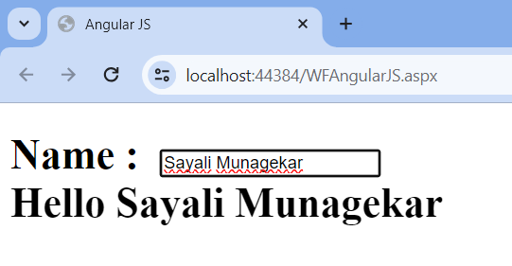

**Enter Data Here**

**Q.9 Design asp.net web form to demonstrate AngularJS (download and use local library).**

**Code:**

**WFAngulaJs.aspx**

<%@ Page Language="C#" AutoEventWireup="true" CodeBehind="WFAngularJS.aspx.cs" Inherits="PracticalNo2All.WFAngularJS" %>

<!DOCTYPE html>

<script src="/Scripts/angular.min.js"></script>

<!-- <script src="//ajax.googleapis.com/ajax/libs/angularjs/1.8.2/angular.min.js"></script> -->

<html xmlns="http://www.w3.org/1999/xhtml">

<head runat="server">

<title>Angular JS</title>

</head>

<body>

<form id="form1" runat="server">

<div ng-app="">

<h1>

Name :&nbsp;

<asp:TextBox ID="TextBox1" runat="server" ng-model="name"></asp:TextBox>

<br />

Hello {{name}}

</h1>

</div>

</form>

</body>

</html>

**Output:**



**Q.10 Design asp.net web form to demonstrate NodeJS.**

**Code:**

**Index.js**

'use strict';

var express = require('express');

var router = express.Router();

var getData = function () {

var data = {

'item1': 'https://images.unsplash.com/photo-1563422156298-c778a278f9a5',

'item2': 'https://images.unsplash.com/photo-1620173834206-c029bf322dba',

'item3': 'https://images.unsplash.com/photo-1602491673980-73aa38de027a'

}

return data;

}

/* GET home page. */

router.get('/', function (req, res) {

res.render('index', { title: 'Express', "data": getData() });

});

module.exports = router;

**Index.pug**

extends layout

block content

h1= title

p Welcome to #{title}

script.

var f1 = function() { document.getElementById('myImage').src='#{data.item1}' }

script.

var f2 = function() { document.getElementById('myImage').src='#{data.item2}' }

script.

var f3 = function() { document.getElementById('myImage').src='#{data.item3}' }

button(onclick='f1()') One!

button(onclick='f2()') Two!

button(onclick='f3()') Three!

p

a: img(id='myImage' height='300vh' width='300vw' src='https://media.istockphoto.com/id/513247652/photo/panoramic-beautiful-view-of-mount-ama-dablam.jpg?s=612x612&w=is&k=20&c=4wdOVJPPp3ocrnDM9Bu8EoCz9CPZyJViRMiQ6zCM6P8=')

**PowerShell Debugger Listen With Port( localhost:1337 ):**

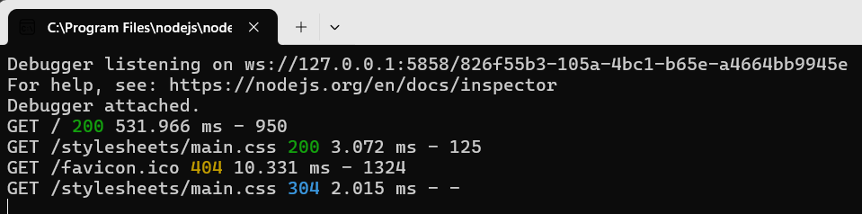

**Output:**

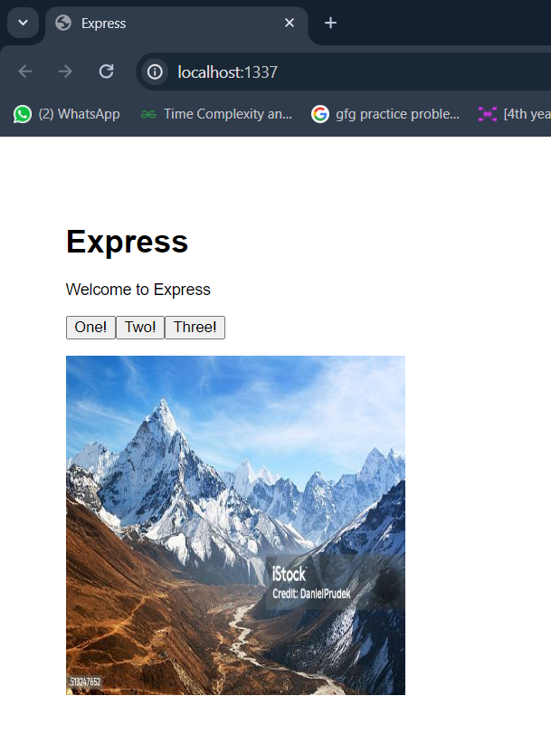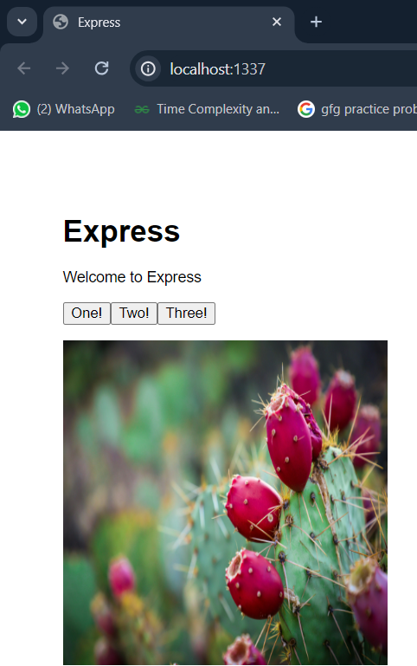

**Click Here One!**

**Default Page**

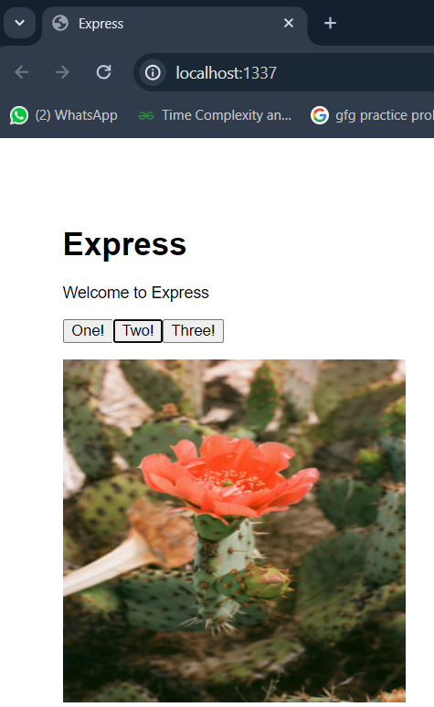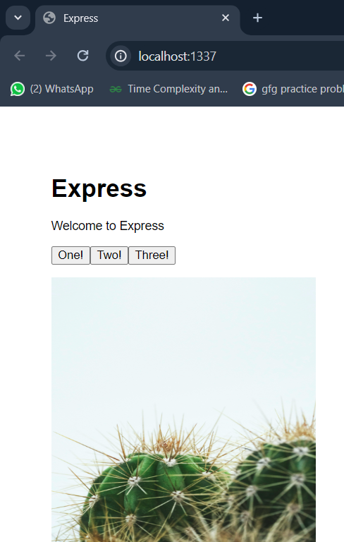

**Click Here**

**Three!**

**Click Here Two!**